Politics, Book VII

THEME OF THE BOOK given in opening remark: to determine the best constitution, we must ascertain the best life

- External goods have a limit in size; the best way of life for a person or a city is a life of goodness duly equipped with external goods. (1323b38) What does Aristotle mean by this?

- 1324a20 – is the best life the life of politics or contemplation? What might be said on each side of the question? What is contemplation? (On this, see also 1325b18ff.)

- 1325a1 – Might think that the best constitution is one ordered toward conquest and that such a constitution would form citizens toward that end. We therefore get an argument that the end of the best constitution cannot be conquest: a city in isolation can still be good.

See point b.below about 1325b18ff.

- 1325a30 – returns to the distinction between mastery over slaves and mastery over free men

  - What is the relevant difference in virtue of which the latter is noble?

      - Free men are one’s equals?
      - One cannot coerce free men?
      - Free men have wills of their own? Practical reason of their own?

Why do any of these things matter? Is it achieving results through persuasion and negotiation, bringing about a harmony of free wills?

      - Why is ruling and being ruled so important? Why not leave ruling to a professional class, just as we do medicine, say?

- 1325b18ff. – very important claims about activity and the best life.

  - What is activity? What is the contrast term – production? Inactivity? Contemplation? Mindless reverie? Loss of the self in dissolute pleasure?

      - Interesting argument contemplation is itself an action
      - Why should activity be an end?

  - What activity is the good of the city – a self-sufficient life in which citizens give each other justice?

Cf. Rawls’s view that peoples need only the resources necessary to sustain democratic institutions. An ever-rising standard of living is not necessary as a matter of justice.

Note what a challenge to ways the ends of politics historically thought of:

- Glory = how one’s state is thought of my others – cf. Augustine on Rome
- Immortality = how one’s state will be regarded by history
- Conquest – driven by desire to dominate
- Pride – how citizens can see themselves
- Having the best or the biggest, e.g. cathedral – the Florence-Siena rivalry.
- Various ways of proving that one’s governing ideology is best – communist v. capitalist rivalry
- Fulfilling manifest destiny of some kind
- Ever-rising standard of living

Would this be stultifying? What improvement is possible? What are citizens to hope or to work for?
- Aristotle makes some very interesting remarks about the optimal size of the city:

  - 1326b1 – a city should be large enough to be self-sufficient. What does self-sufficiency mean?

  - 1326b20 – note Aristotle’s concern with voter fraud!

  - Look at Josh Ober’s table for population and wealth in late 4th century Athens:

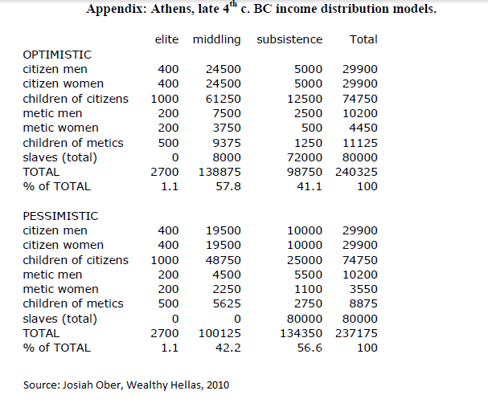
      - At 1326b15, Aristotle says that “each citizen must know what sorts of people the other citizens are”. How much specific mutual knowledge is required to satisfy this condition? If a great deal, does this condition impose upper limits on the size of the city? Is Athens itself too large?

      - In chapter 7, Aristotle contrasts the characteristics of peoples from various parts of the world he knew. In this connection, it is useful to look at recent work on the so-called “lucky latitudes”.

      - Note the sharp distinction between leisure and necessity at 1331b10-12. What does ‘necessity’ mean? Note that it cannot mean the same thing that it means at 1332a15.

      - Aristotle implies at 1328b40 that some lives are inimical to virtue. The table raises the question of how many Athenians in Aristotle’s time had the leisure he says is needed for virtue. (see also 1334a35)

- At 1329b40-41, Aristotle famously implies that property should privately held but commonly used. What does he mean? How do you think he would defend this view? Is it realistic?

- Aristotle opens the last paragraph of chapter 13 by saying that people become excellent because of three things.

  - What are the three? What does it mean to say they must be harmonized?

  - We saw earlier that Aristotle thinks a good life is a life of virtue. Where does virtue fit into the account of excellence described in this paragraph?

  - Recall that Rawls says virtues are qualities of character it would be rational for citizens of a well-ordered society to want in one another. Recall, too, that in giving this definition, Rawls presupposes the full theory of goodness. Do you think Aristotle would agree with Rawls’s definition? Why or why not?

- Note Aristotle’s various eugenics policies in chapter 16.

- The last chapter of Book VII is devoted to the moral education of children. Rawls, as you’ll recall, dedicates three chapters to moral development.

  - Do the two take up moral education or development for the same reasons?

  - Compare and contrast the two discussions.

These figures no doubt include those who lived outside the city of Athens; I don’t know how much of the Athenian population was urban. Note further that while Ober is a very reputable scholar, estimates of the population of ancient Athens vary widely. Ian Morris, The Measure of Civilizations says that Babylon was the most populous city of Aristotle’s time and he gives a figure of 150,000 – far less than Ober’s figure for (the smaller) Athens.

